BSCS FINAL PROJECT
Requirements Specification

Defense Drill



Project Advisor

Rubab Javaid

Presented by:
Group ID: F22SE046

Student Reg# Student Name
L1F19BSSE0128 Abdul Moiz Adnan
L1F19BSSE0132 Hassan Islam
L1F19BSSE0303 Rimsha Ghafoor

Faculty of Information Technology

University of Central Punjab
Software Design Specification
SDP Phase II

Defense Drill
Advisor: Rubab Javaid

Group id: F22SE046
Member Name | Primary Responsibility
Hassan Islam | 2(All),3(All)
Abdul moiz adnan | 4(All)
Rimsha Gafoor | 1(All)

Table of Contents
Table of Contents i
Revision History ii
Abstract 1
1. Introduction 1
1.1 Product 1
1.2 Background 1
1.3 Objective(s)/Aim(s)/Target(s) 1
1.4 Scope 2
1.5 Business Goals 2
1.6 Document Conventions 2
2. Overall Description 3
2.1 Product Features 3
2.2 Functional Description 3
2.3 User Classes and Characteristics 5
2.4 Design and Implementation Constraints 5
2.5 Assumptions and Dependencies 5
3. Technical Architecture 6
3.1 Application and Data Architecture 6
3.2 Component Interactions and Collaborations 10
4. Screenshots/Prototype 12
4.1 Workflow 12
4.2 Screens 13
5. Revised Project Plan 19
6. References 19
Appendix B: IV & V Report 20

Revision History
Name | Date | Reason For Changes | Version

Abstract
Now a days due to rampant crimes in the country which have no end in sight, ordinary citizens are being caught up in situations they are not ready for. They are unable to protect themselves and those close to them because they do not have the required skillset to remain calm and act in accordance to avoid getting hurt, robbed, or killed. To counteract that we have developed an app which has courses for beginners as well as advanced users which will provide the user with the skillset to at-least defend themselves in dangerous situations.

At the end, the results that would be acquired are: provided the user with ability to defend themselves and make a citizen not so helpless in dangerous situations anyone. Intermediate users and advanced users could be eligible for a career in mixed martial arts by participating in a tournament to test their ability according to their badge levels.

Introduction

Product
Our project solves the problem plaguing our nation i.e., people having no form of self-defense/self-preservation ability. Our app provides that skill that is obtainable even after completing the most beginner course we offer.

Background
This Project aims to provide ordinary citizens with the knowledge and skill of self-defense. The tutors will also be able to sign up and upload their portfolios. The users will interact with the tutors through online seminar. This project provides the user beginner and if the user wishes to learn more, advanced skills which would enable the user to protect themselves and their loved ones in a dangerous situation. Complete new animations made by us to provide a visual representation of the martial arts move. The project also provides notifications of tournaments to pit users against each other according to badge/skill level. Freelance martial arts tutors can also hugely benefit from providing one-on-one lessons to confirming skill level for a fee. The app has image processing to ensure correct repetition of moves. This project has an app based designed to run efficiently on all systems with accurate responsiveness.

Objective(s)/Aim(s)/Target(s)
- We will make an app that provides a three-course program that teaches martial arts from beginner to the advanced level.
- The app would contain one-to-one video call for students and tutors. An image processing module to calculate repetitions.
- A badge system that will award badges based on course completion. The ability to create an account for both the student and tutor.
- Complete new animations made by us to provide a visual representation of the martial arts move. Complete documentation and code of project

Scope
We will make an mobile and web app that provides a three-course program that teaches martial arts from beginner to the advanced level. The app would contain one-to-one video call for students and tutors. An image processing module to calculate repetitions. A badge system that will award badges based on course completion. The ability to create an account for both the student and tutor. Complete new animations made by us to provide a visual representation of the martial arts move. Complete documentation and code of project

Business Goals
Our main business goals are:
- To provide martial arts training who cannot afford training institutes and outdoor tuitions.
- To provide earning platform for trainers.
- To provide free courses and paid online classes for trainee.

Document Conventions
This document uses the following conventions:

DDRL | Defense Drill
Main headings | Size 18 bold times new roman
Sub headings | Size 14 bold times new roman
Headings content | Font size 12 style Ariel

Overall Description

Product Features
The major features of our application is:
- Enrollment or register
- Daily activity
- Self-made animations
- schedule for a week/month
- levels of training beginner intermediate and advanced
- Push Notifications and Reminders
- progress tracker
- score of daily activity
- badge levels
- online couching
- repetitions counter

Functional Description
DFD level 0:

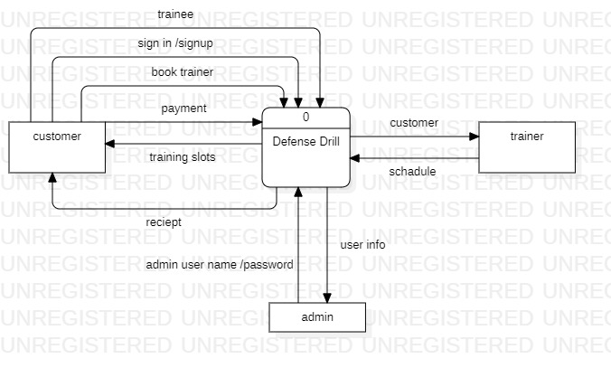

DFD level 1:

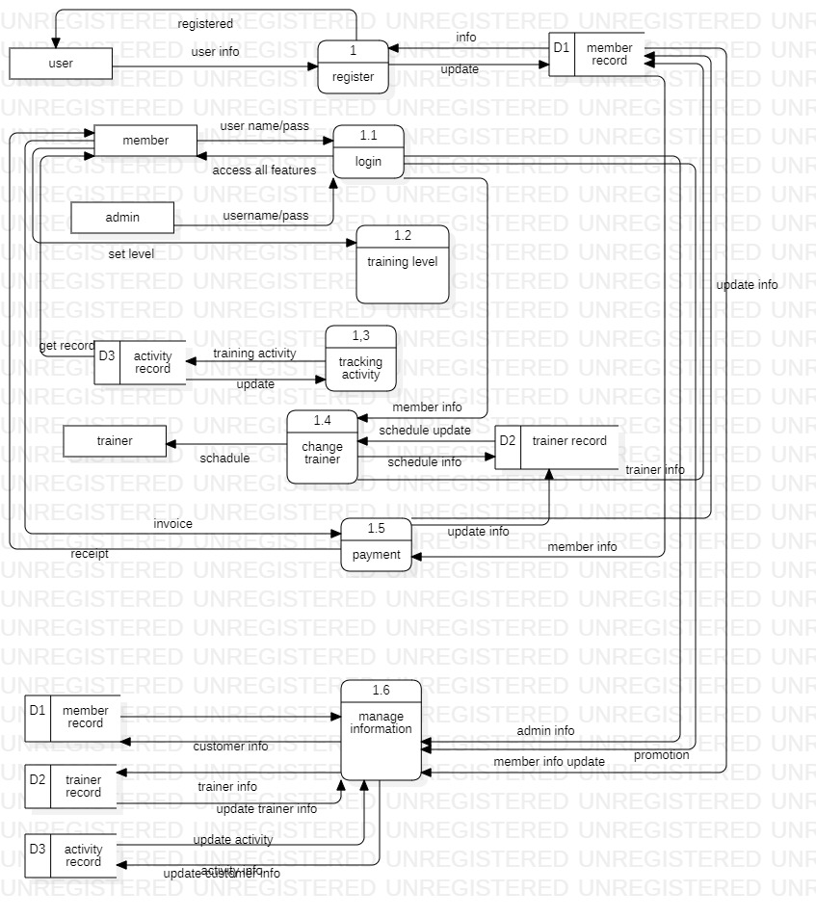

User Classes and Characteristics
We have 2 levels of users

- User module: This is a normal level of user who will be very few number of functionality for website and mobile application.
- Administration module: This user is an admin type who has full rights on the system

Design and Implementation Constraints
- The information of all users like schedule, activity and self-made animations must be stored in database that is accessible by the website and mobile application.
- SQ lite will be used as database.
- User may access its web from any computer that has internet browsing capabilities and an internet connections and on smart phones mobile app must be installed.
- Smart phone memory should be above 2 gb for smooth running of Defense drill Application.
- Camera specs must be above 8 megapixel for repetition counting without any error.
- Users must have their correct usernames and passwords to enter into their online profile and do actions.
- Language requirements: software must be multilingual, including the following Languages: English, urdu and Hindi.
- This app must be able to access the devices GPS to offer location based couching facilities

Assumptions and Dependencies
- If no internet connection is available, users will be unable to log in or access any functionality of the app.
- This project needs the following third party product
- SQ lite database for storing data
- Unregistered users will have no access to the app.
- Users will only be permitted to register and gain access to the app once they agree to the terms of service agreement.

Technical Architecture

Application and Data Architecture
Architecture Diagram

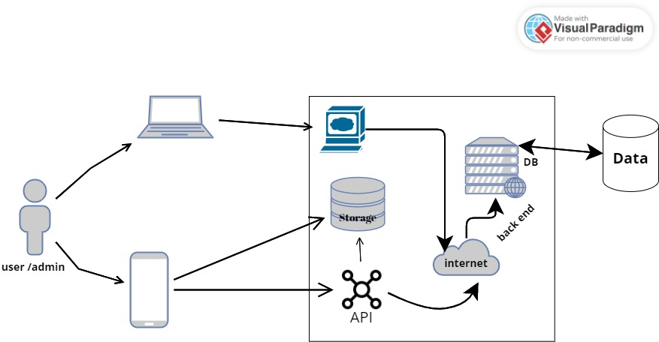

ERD diagram:
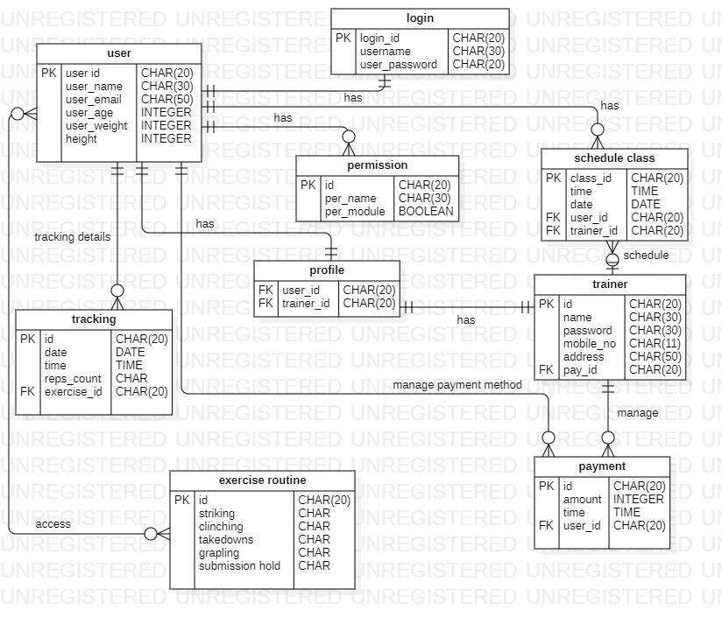

Class Diagram:
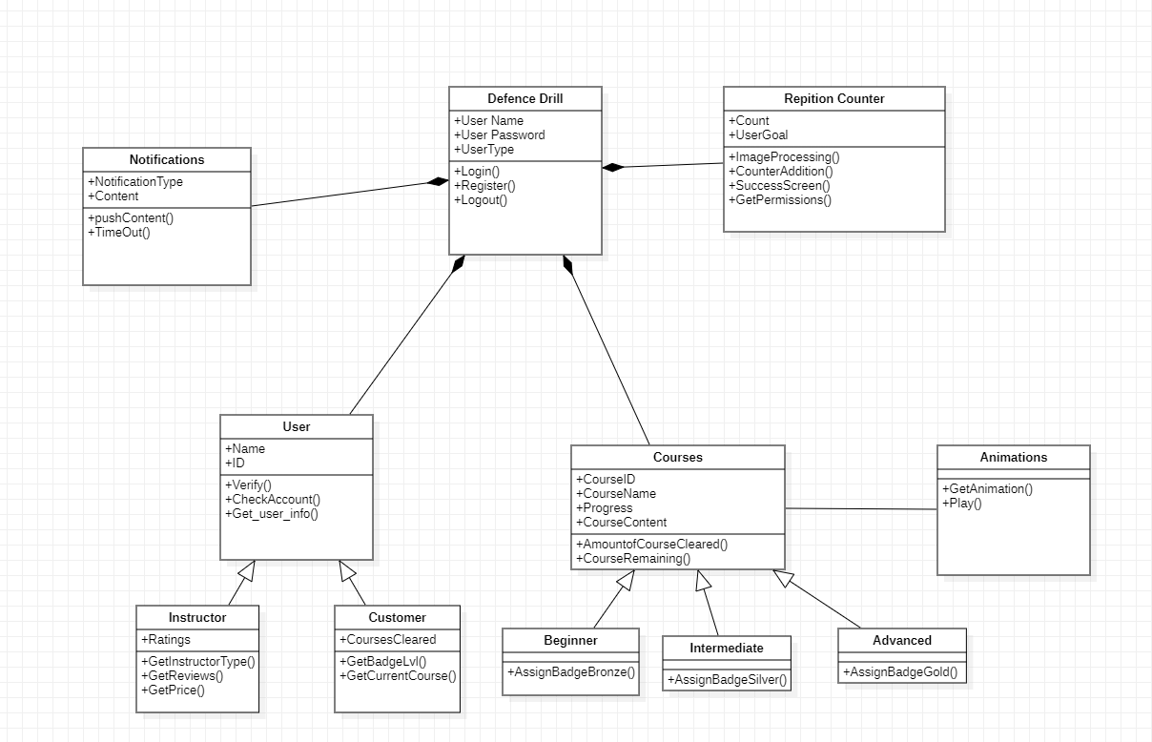

Activity Diagram:

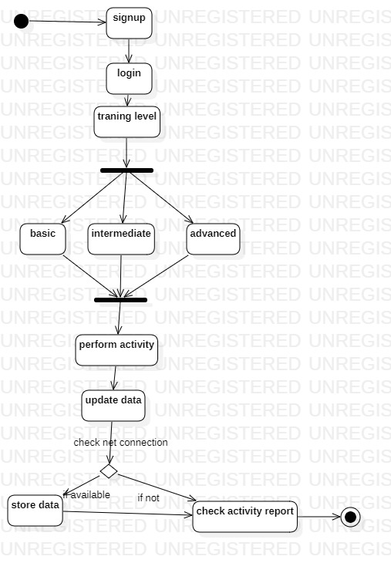

Component Interactions and Collaborations
Component Diagram:
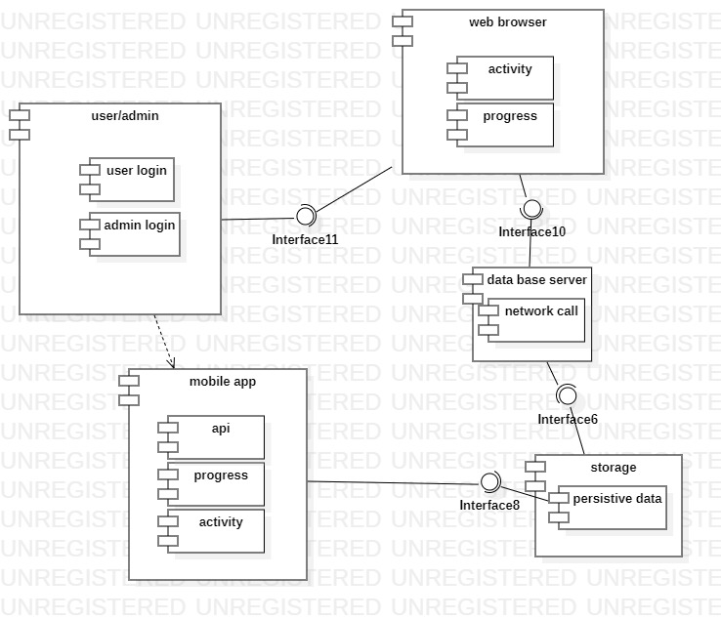

Sequence Diagram:

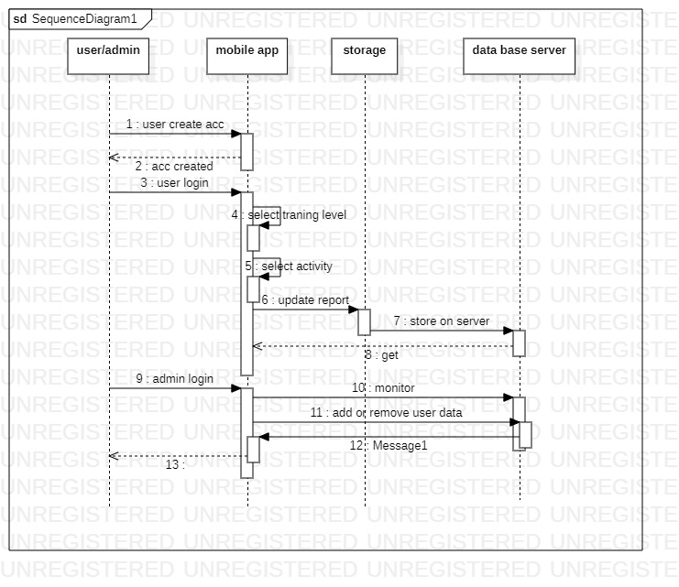

Screenshots/Prototype

Workflow
Swimlane:
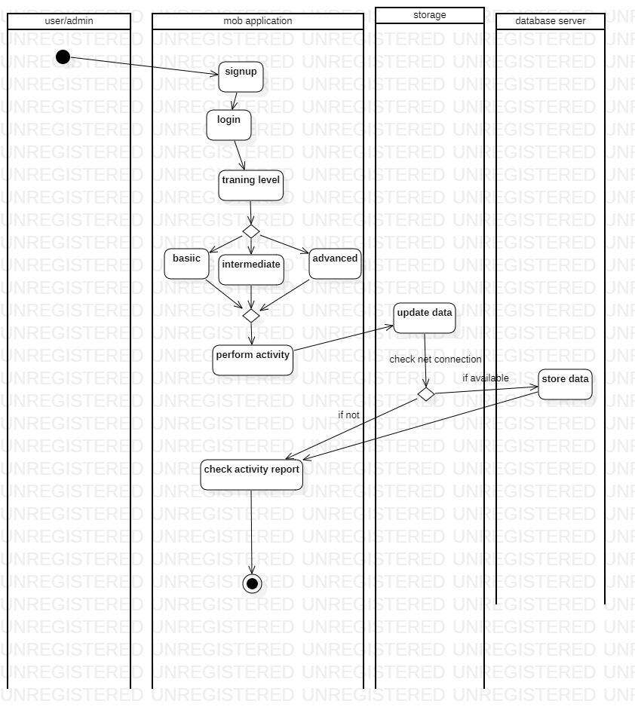

Screens
Sign in/ Sign up

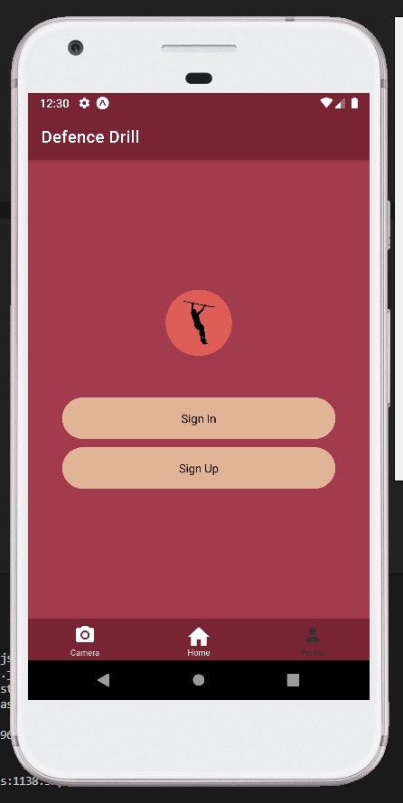

Sign up

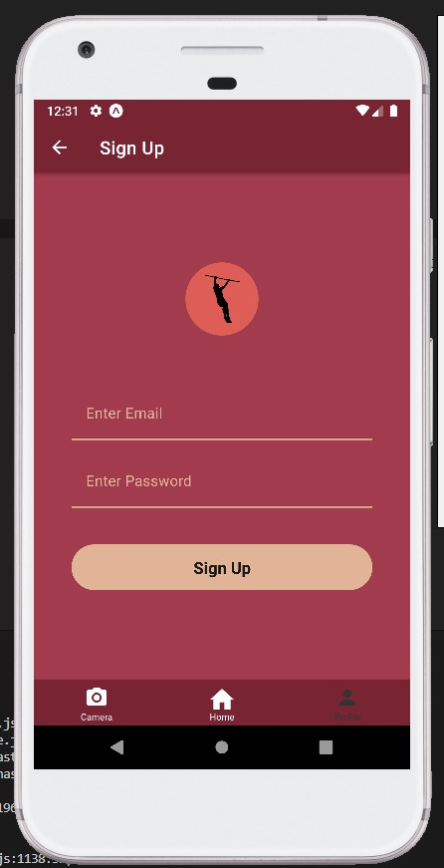

Sign out:
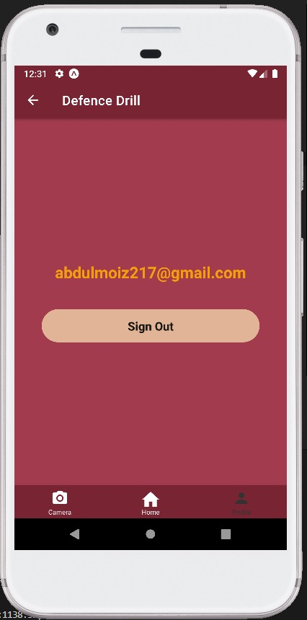

Levels
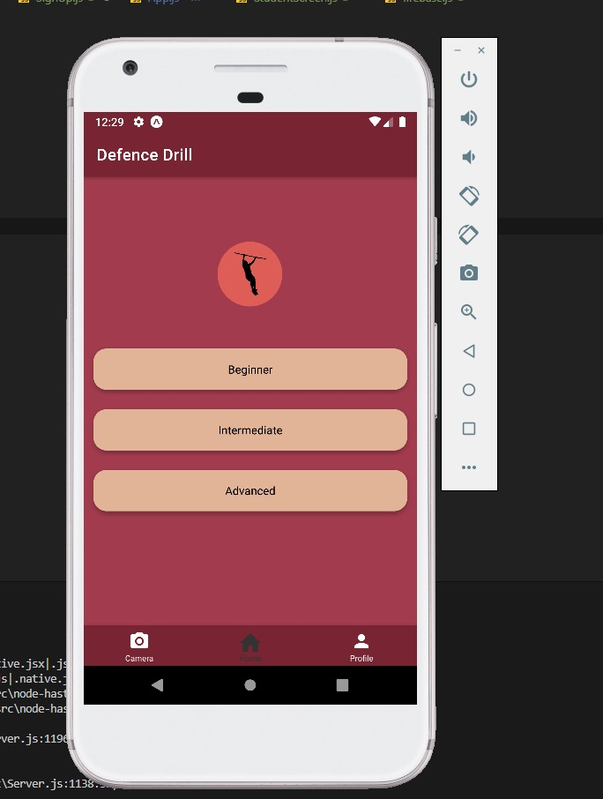

Beginner
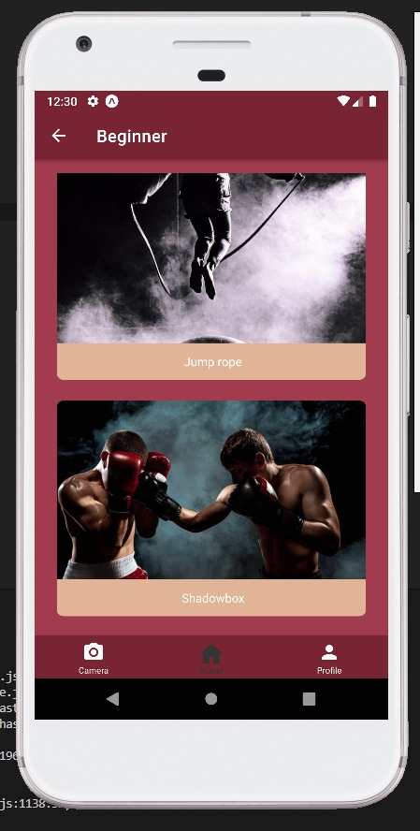

Intermediate
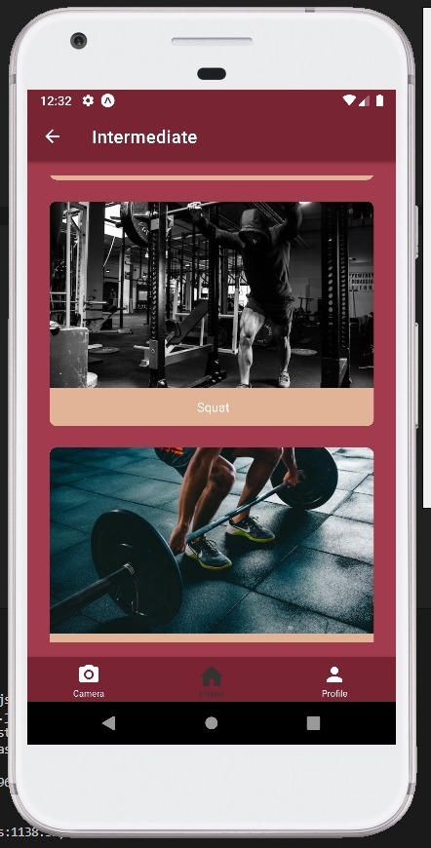

Camera:

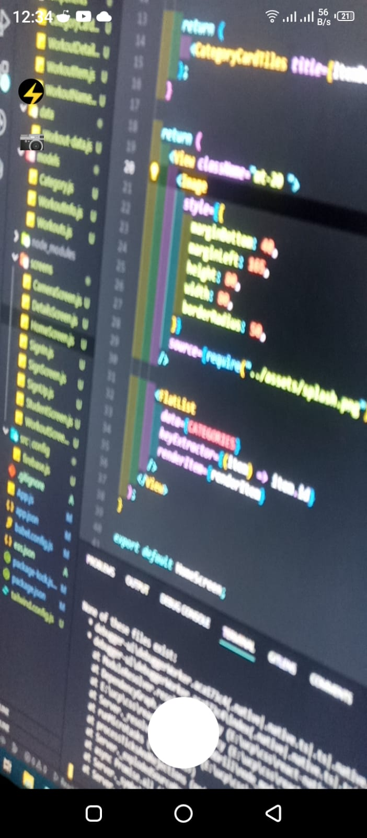

Revised Project Plan
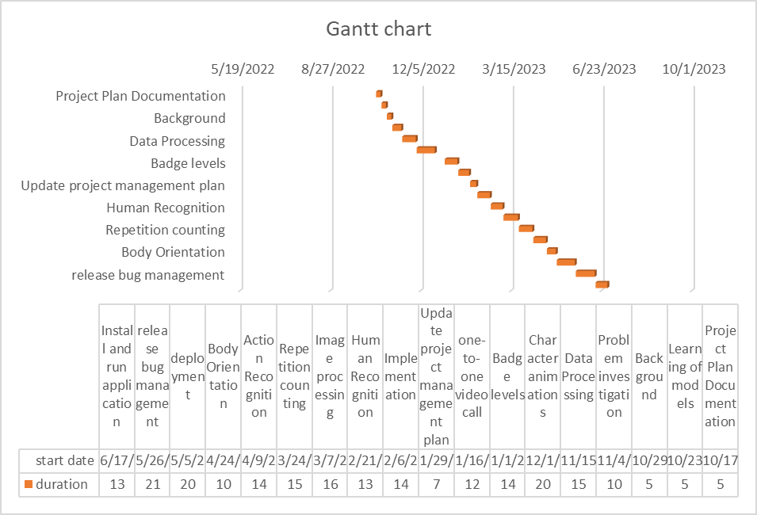

References
- [1]Free AWS Architecture Diagram Tool (visual-paradigm.com)

- [2] https://krazytech.com/projects

- [3]App Development 101 - Software Requirements Specification | Altamira Developers

Appendix B: IV & V Report
(Independent verification & validation)
IV & V Resource

Name Signature

S# | Defect Description | Origin Stage | Status | Fix Time
 |  |  |  | Hours | Minutes
1
2
3
…
Table 1: List of non-trivial defects

This document has been adapted from the following:
- Previous project templates at UCP
- High-level Technical Design, Centers for Medicare & Medicaid Services. (www.cms.gov)

